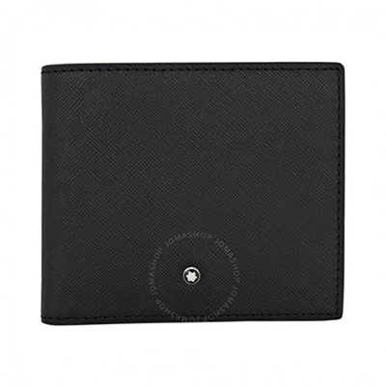

Montblanc Sartorial Bi-fold 4CC Leather Wallet

PRODUCT DETAILS

**A Montblanc sartorial wallet crafted in Italian full-grain calfskin leather. This wallet features 4 credit card slots, 2 compartments for banknotes, a coin case and an**

**additional pocket. Dimensions: 4.3" x 3.7".**